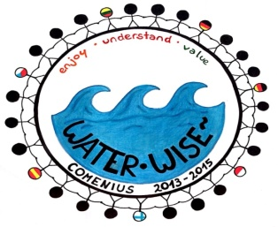

COOKING TIME
Country:Lithuania
Recipe name:Pancakes from potatoes

Ingredients for 4 people:10 potatoes, 2 eggs, 1 small onion,2 spoons of flour, some salt; olive oil for frying
Step by step:
First of all, peel the potatoes,
wash them in cold wáter,
then grate them.You’ve got such a mass in a bowl.
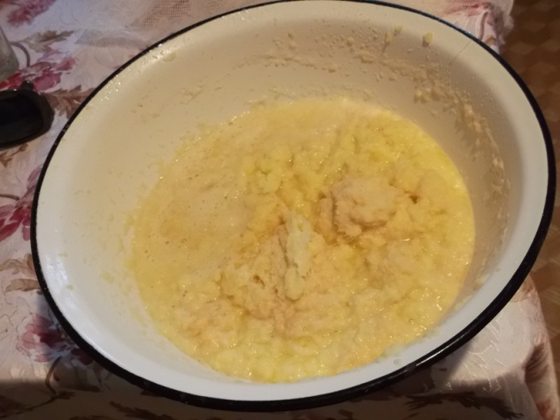

Peel and cut the onion, put it into the mass.
Add eggs, salt, flour and stir carefully.

Take the frying pan, pour some olive oil and fry pancakes.
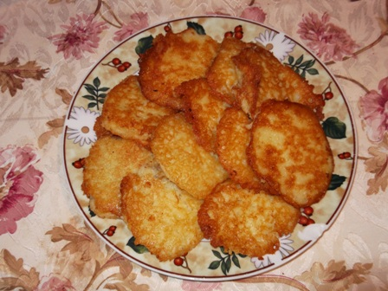
Serve them with cream.
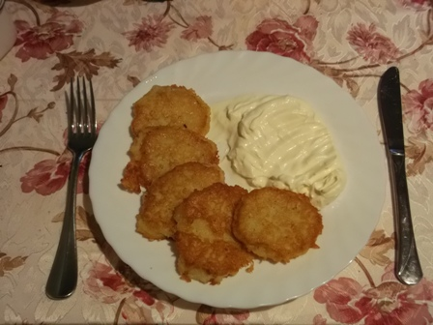

Enjoy yourselves
Goda

